**Assignment 1 Solution**

**STUDENT NAME:**

**Exercise A:**

1. **NameNode UI console first page screen shot**

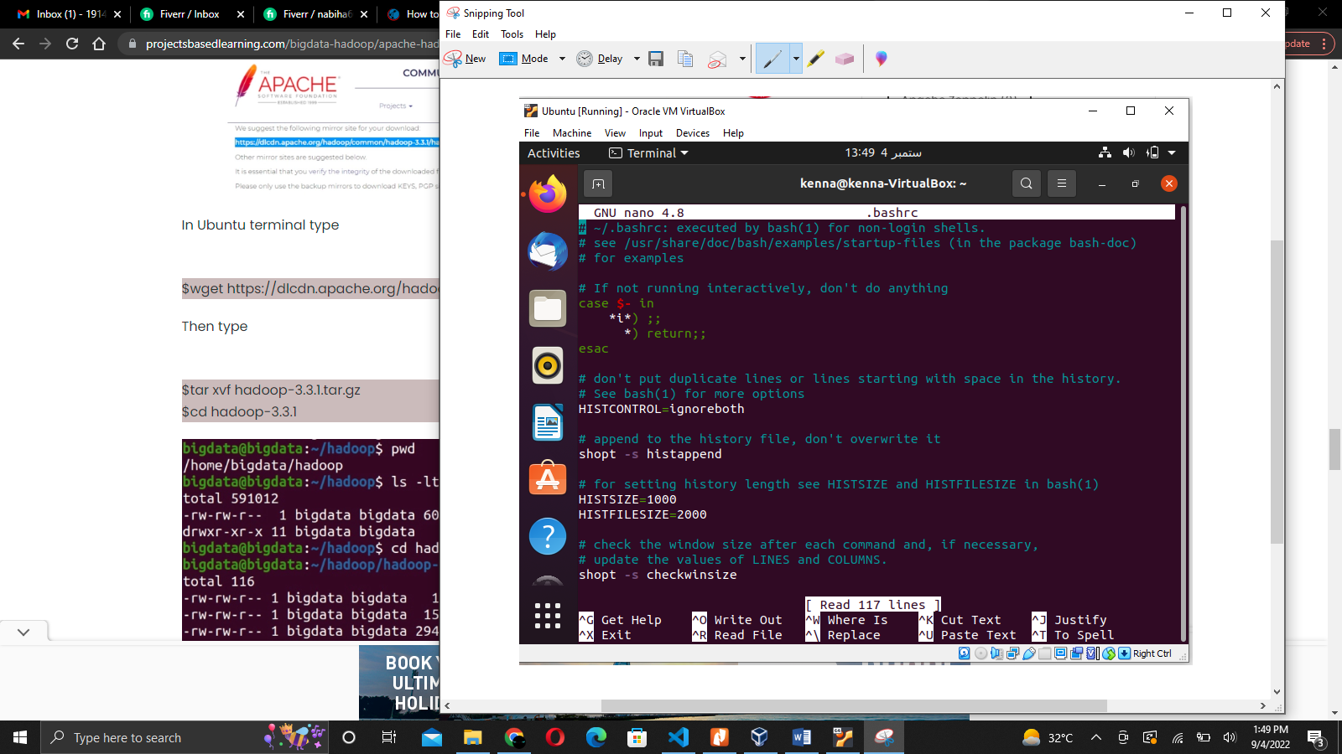

1. **ResourceManager UI console first page screenshot**

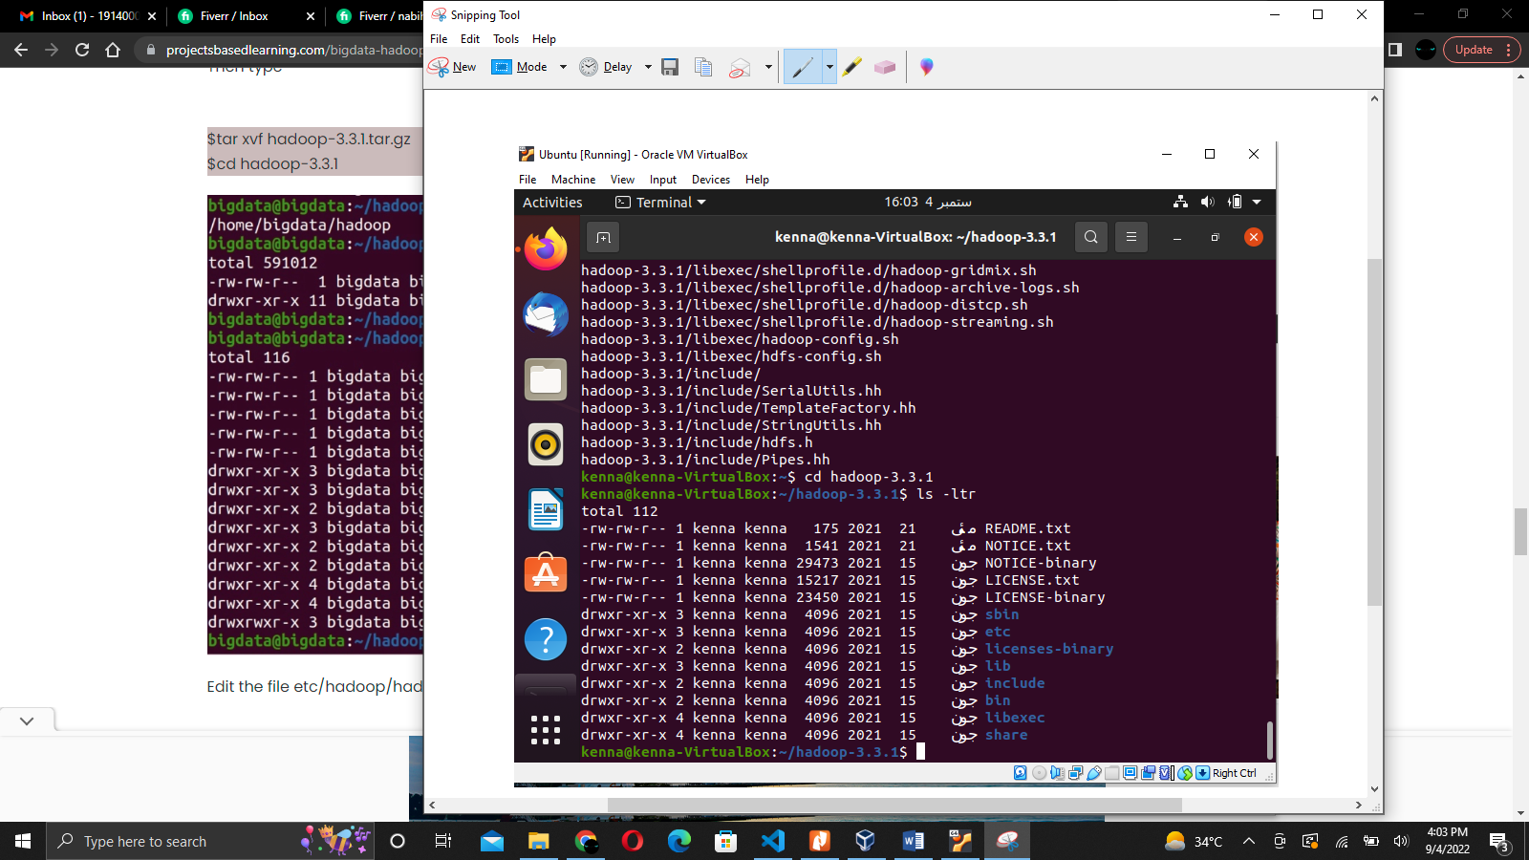

1. **JobHistoryServer UI console first page screen shot**

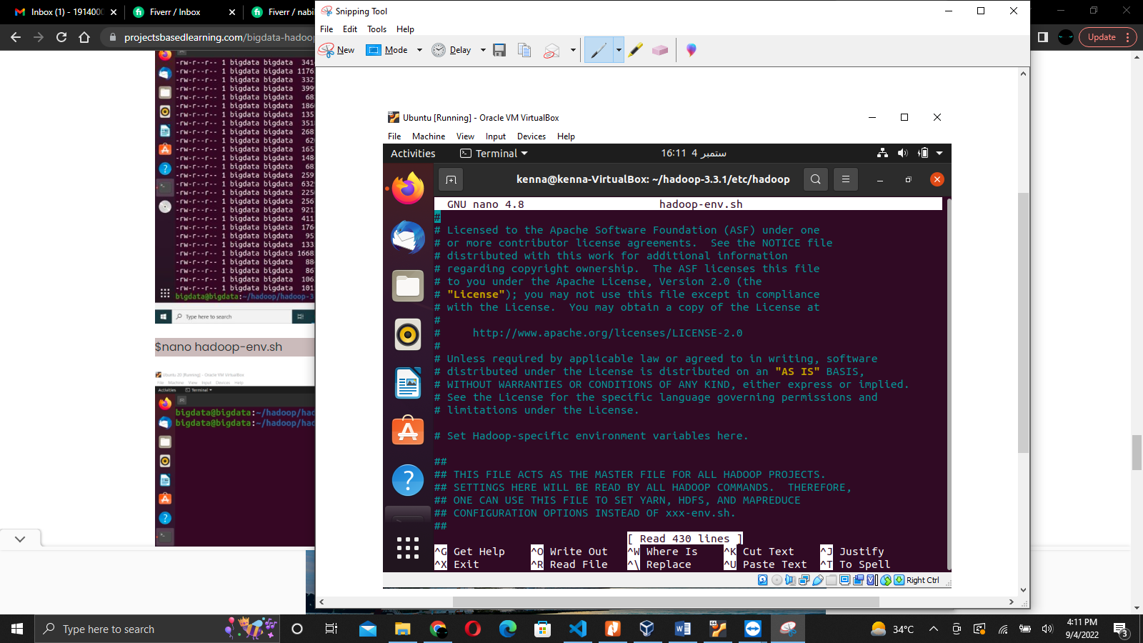

1. **A screen shot of jps command output**

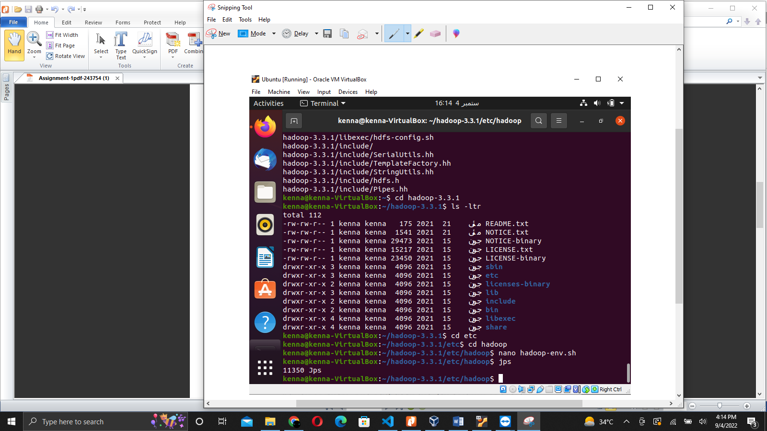

1. **What ports are the various Hadoop daemons listening on? Fill in the table**

|  |  |
| --- | --- |
| **Daemon** | **Ports (comma separated list)** |
| NameNode | 0.0.0.0 |
| SecondaryNameNode | 0.0.0.0 |
| DataNode | 127.0.0.1 |
| ResourceManager | 127.0.0.1 |
| NodeManager | 127.0.0.1 |
| JobHistoryServer | 0.0.0.0 |

1. **How many times does the word “family” appear across all the books?**

The word “family” in lowercase **by itself (no punctuations)**  appears ____20_____ times.